**Lab MST MPI**

**Student Name:** Sahil Kaundal **UID:** 21BCS8197

**Branch:** BE CSE (Lateral Entry) **Section/Group:** 807/B

**Semester:** 4th **Date of Performance:** 22/03/2022

**Subject Name:** MPI Lab **Subject Code:** 22E-20CSP-253

* 1. **Aim/Overview of the practical:**

Subtract the 16-bit number in memory locations 4002H and 4003H from the 16-bit number in memory locations 4000H and 4001H. The most significant eight bits of the two numbers are in memory locations 4001H and 4003H. Store the result in memory locations 4004H and 4005H with the most significant byte in memory location 4005H.

* 1. **Task to be done:**

Subtract the 16-bit number in memory locations 4002H and 4003H from the 16-bit number in memory locations 4000H and 4001H. The most significant eight bits of the two numbers are in memory locations 4001H and 4003H. Store the result in memory locations 4004H and 4005H with the most significant byte in memory location 4005H.

* 1. **Apparatus/Simulator used :**
     + Jubin Application
     + 8085 Simulator
     + JDK
  2. **Algorithm/Flowchart:**
     + 1. Get first 16-bit number in HL.
       2. Save first 16-bit number in DE.
       3. Get second 16-bit number in HL.
       4. Get lower byte of the first number.
       5. Subtract lower byte of the second number.
       6. Store the result in L register.
       7. Get higher byte of the first number.
       8. Subtract higher byte of second number with borrow.
       9. Store 16-bit result in memory location 4004H and 4005H.
       10. Store 16-bit result in memory location 4004H and 4005H.
       11. Terminate program execution.

# Description/ Code:

LHLD 4000

XCHG

LHLD 4002

MOV A, E

SUB L

MOV L, A

MOV A, D

SBB H

MOV H, A

SHLD 4004

HLT

# ORG 4000

# DB 90,70,10,30

* 1. **Result/Output/Writing Summary:**

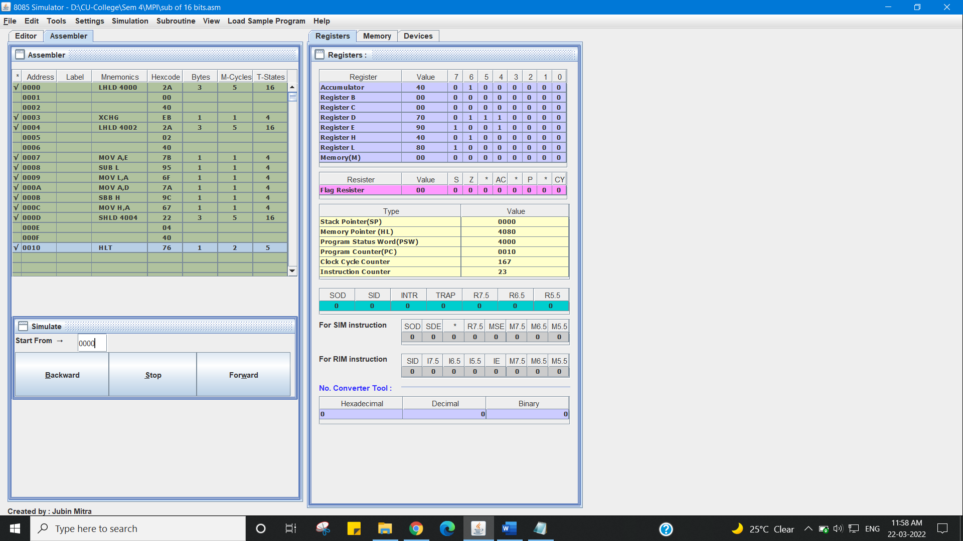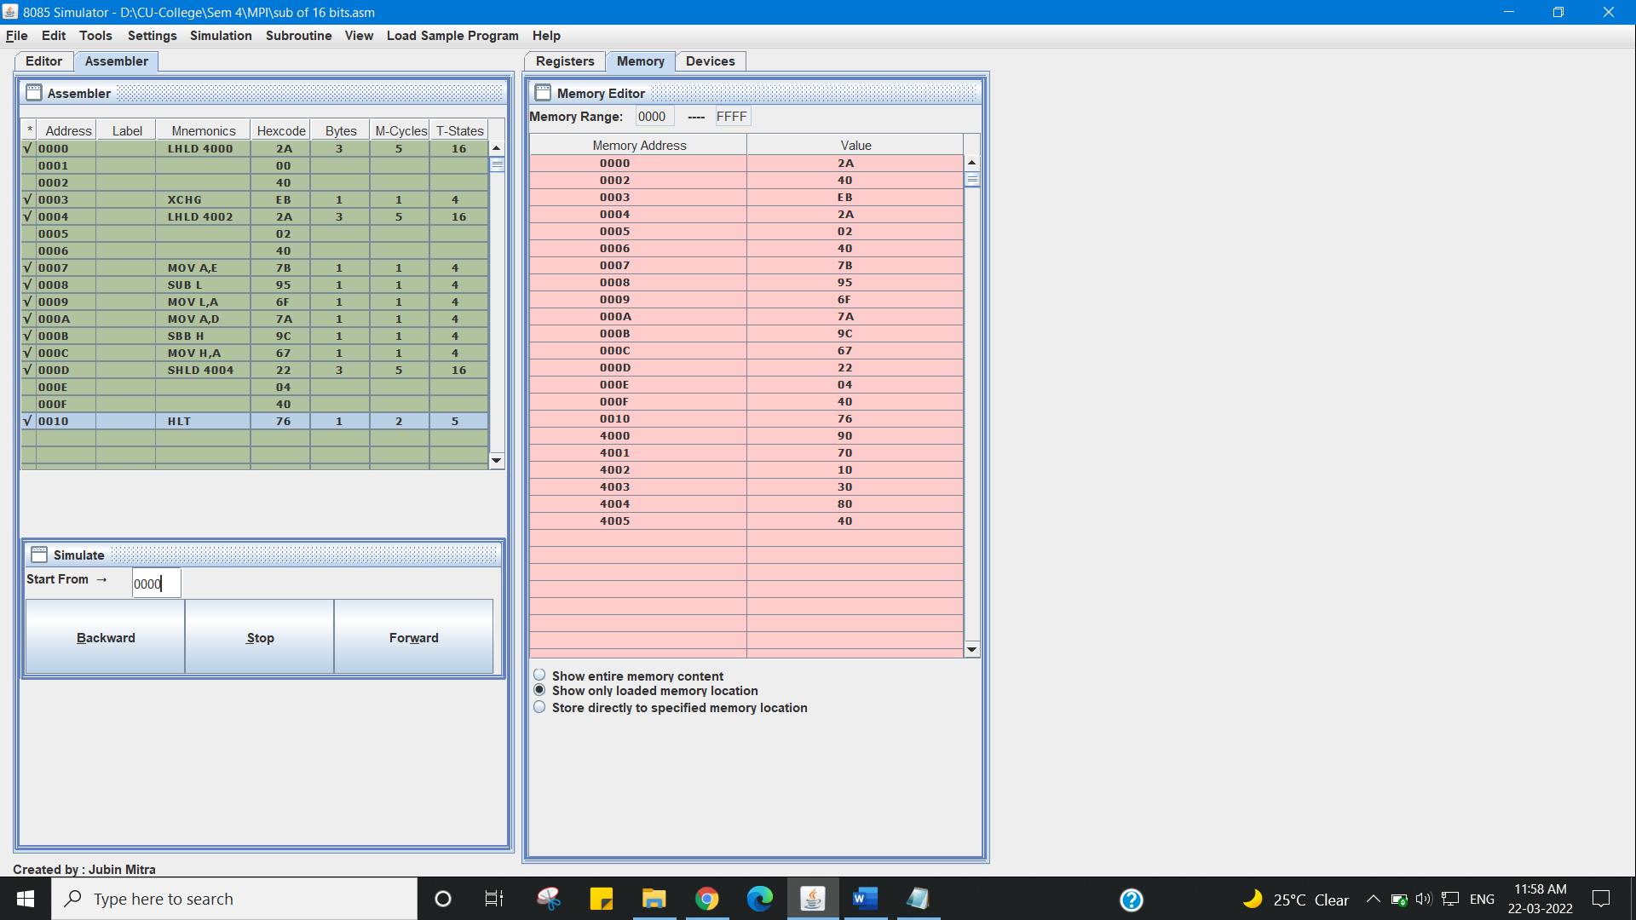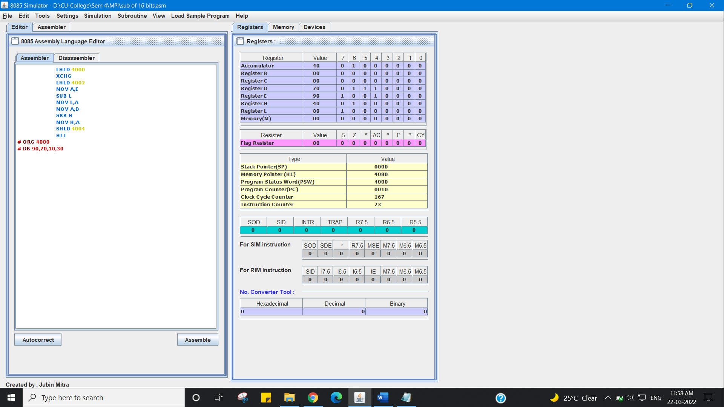

**Learning outcomes (What I have learnt):**

1. Working of microprocessors.
2. Learn how to do mathematical operations in microprocessors.
3. Learn about 8085 simulator.
4. Subtraction of two 16 bit numbers.
5. Learn about the different instructions that are needed to be given to the memory to perform some tasks.

**Evaluation Grid (To be created as per the SOP and Assessment guidelines by the faculty):**

|  |  |  |  |
| --- | --- | --- | --- |
| Sr. No. | Parameters | Marks Obtained | Maximum Marks |
| 1. |  |  |  |
| 2. |  |  |  |
| 3. |  |  |  |
|  |  |  |  |